Section 12 website design

Moods of the color palette

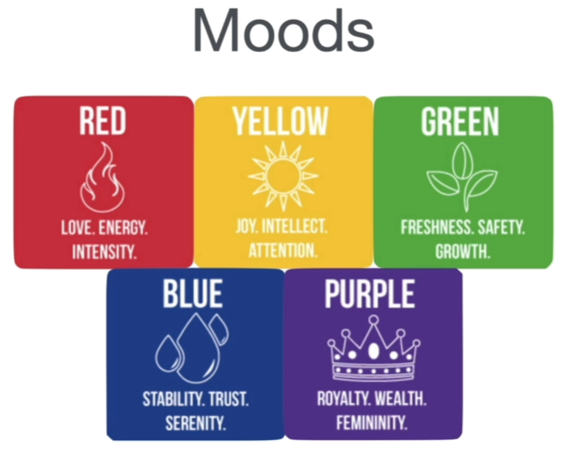

Analogous color palettes are harmonious

Navbars, bodies , backgrounds

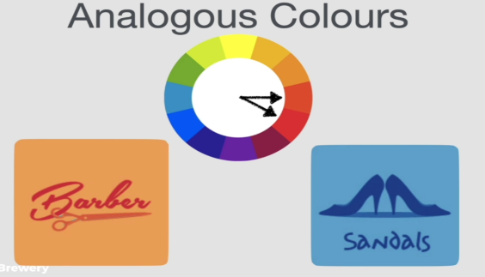

Complementary Colors – Pop

AKA clashing colors, adds pop - like in the meat isle at the grocery store

- green/red

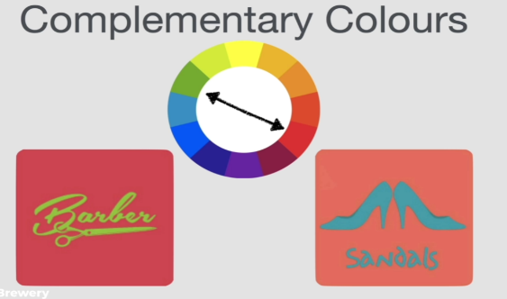

Don’t use for text/backgrounds Color discord

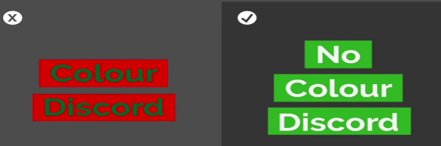

Can use adobe color to try out other color schemes

<https://color.adobe.com/create/color-wheel>

70 Understanding Typography and how to choose a font

Consider mood, combining

Serif – has the feet, use for a more authoritative look and feel.

Look at the thickest and thinnest part of letter – Modern serif fonts show more exaggeration between the thinnest and thickest parts of the letters.

non serif

Emotions behind the fonts

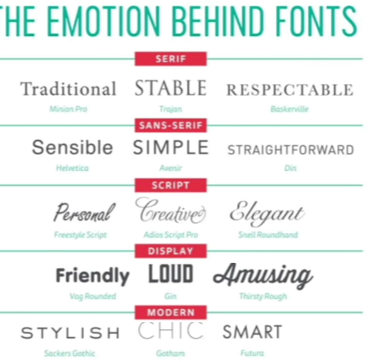

The title of vogue magazine is a modern serif typeface

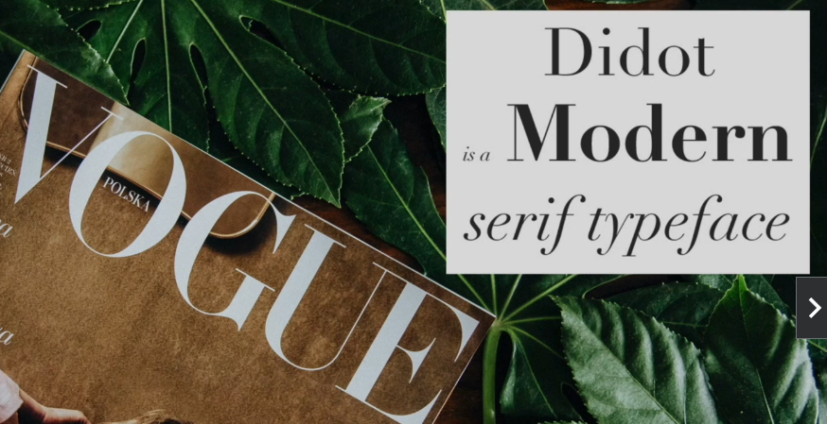

Many startups like to use a sans-serif type face for its right angles – friendly and approachable, novel and contemporary

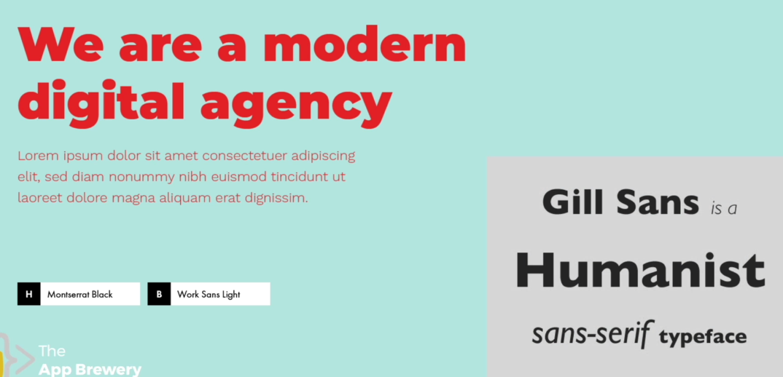

Humanist is a family of sans serif typeface that is highly readable typeface

Even if a company ops for serif for a title , it will often use sans-serif for body for readability.

Some other familys in sans serif Groutesque, non Groutesque, Humanist, Geometric

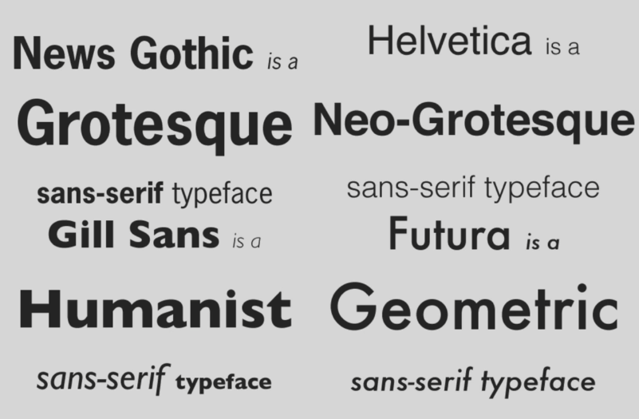

Humanist vs groutesque type face dashboard – humanist was easier to read

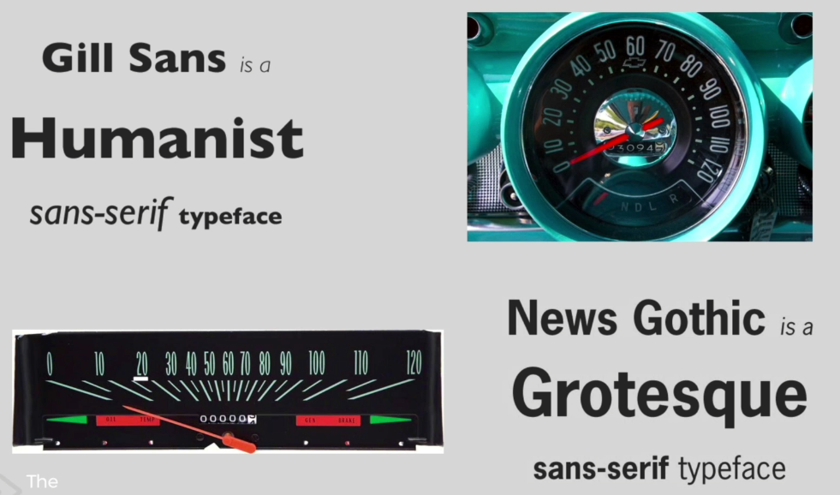

Humanist type faces are very readable good to use in body

Readability and legibility are very important

Legibility has to do with open shapes, ample intercharacter spacing, unambiguous forms and varying proportions.

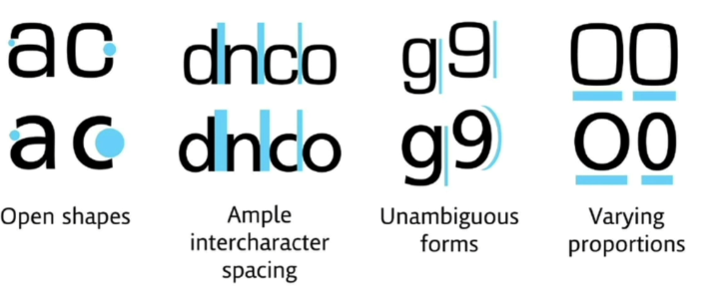

It is important to not use too many fonts , it looks cluttered and overly complicated not nice. A small selections keeps design cleaner, clearer and easier to digest.

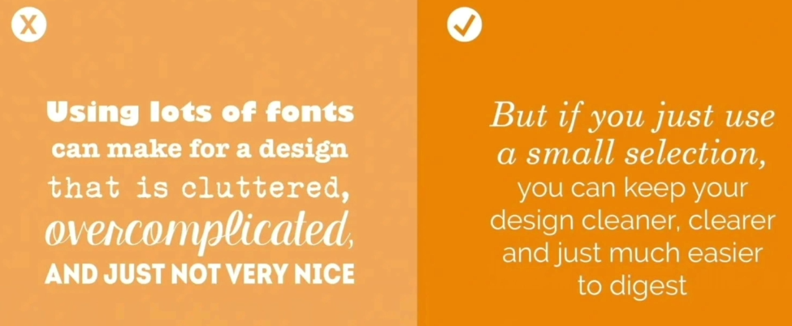

Keep it at 2 fonts

When combining fonts look for similar mood and time era but contrast the serif-ness in like titles and bodies. Could also create interest by changing up the weights

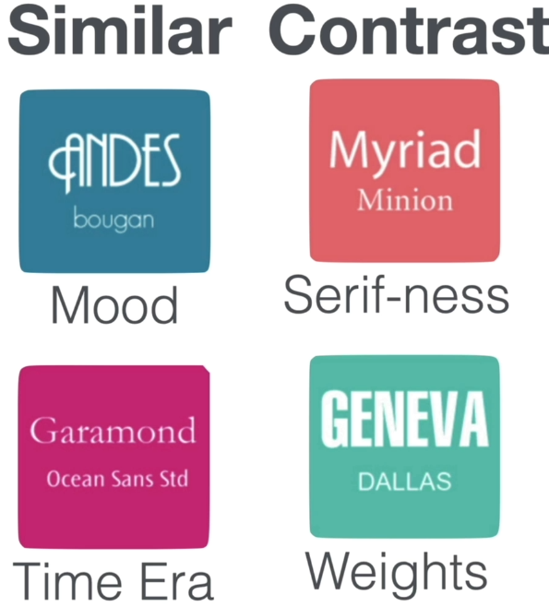

Do not use these fonts

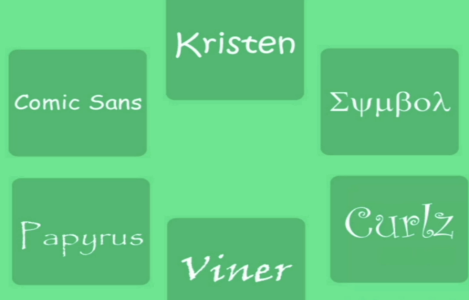

71 Manage attention with effective user interface design

Convery the most important info first

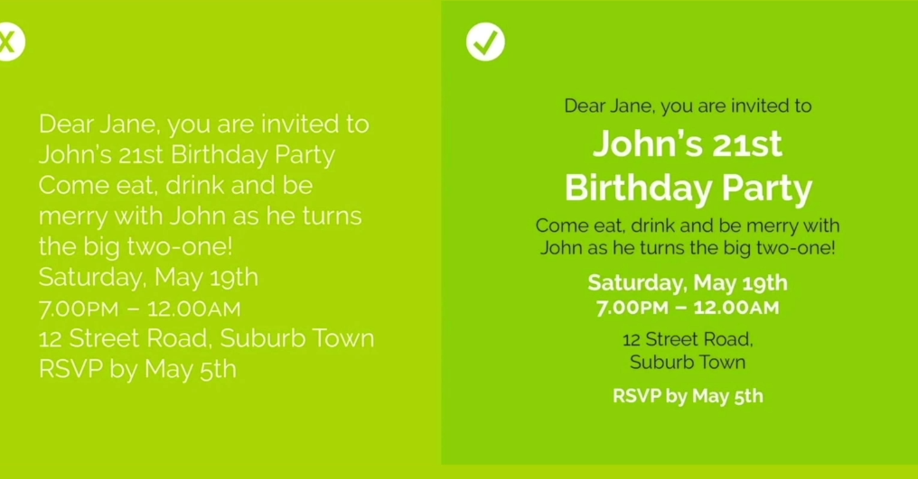

Can convey hierarchy using

Color –

Pop , color contrast

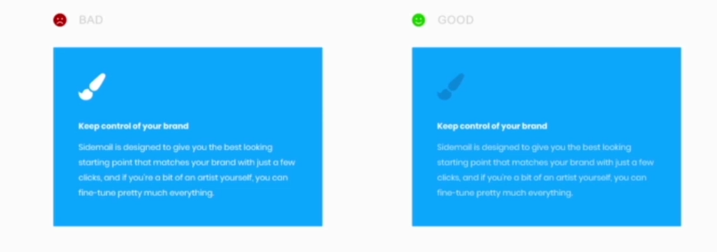

Size

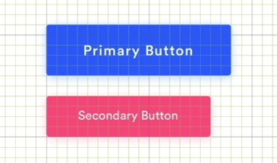

Can convey hierarchy using the layout 

Aim for 40 to 60 characters per line as the line length for best readability 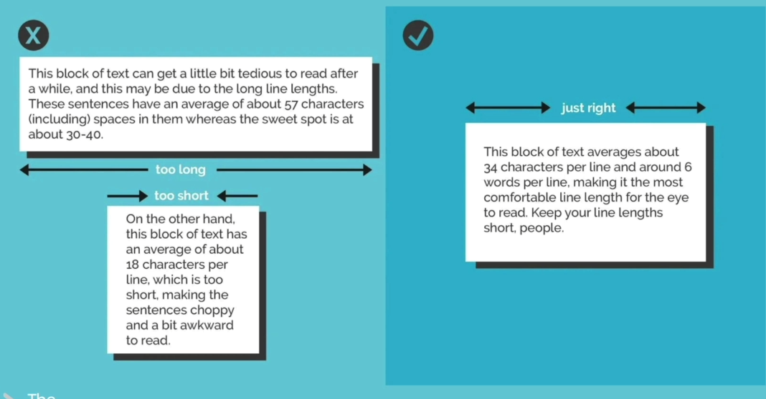

Alignment – how elements are positioned on the screen relative to each other

More is less – one easy way to make design look more professional is to reduce the number of alignment points

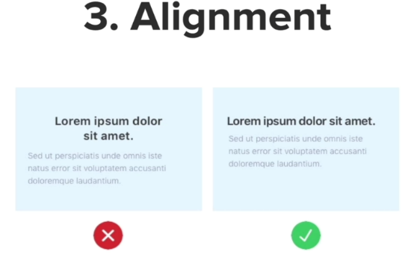

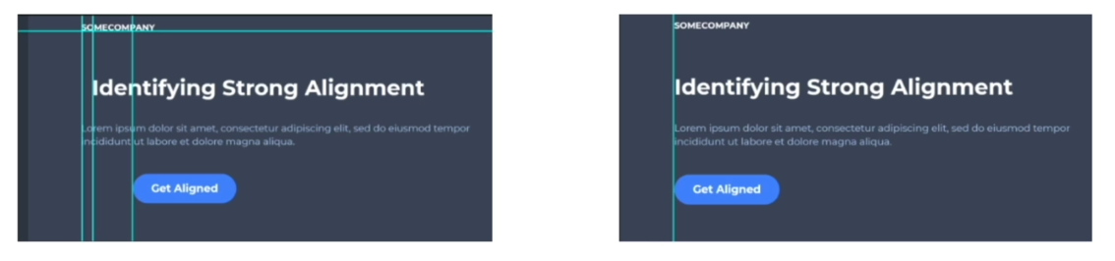

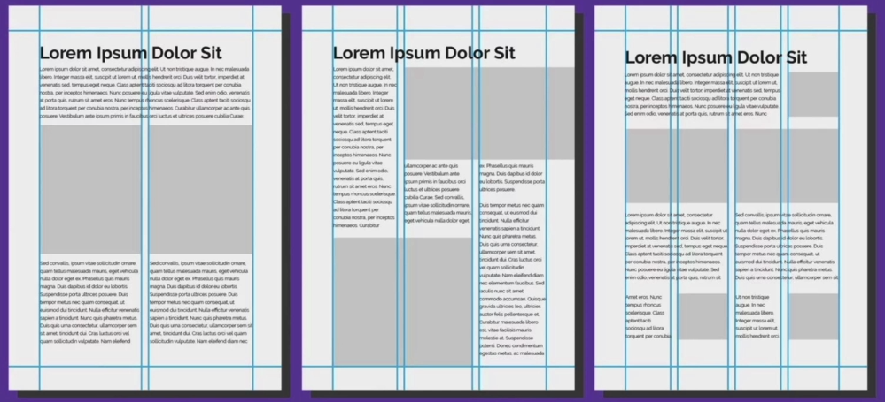

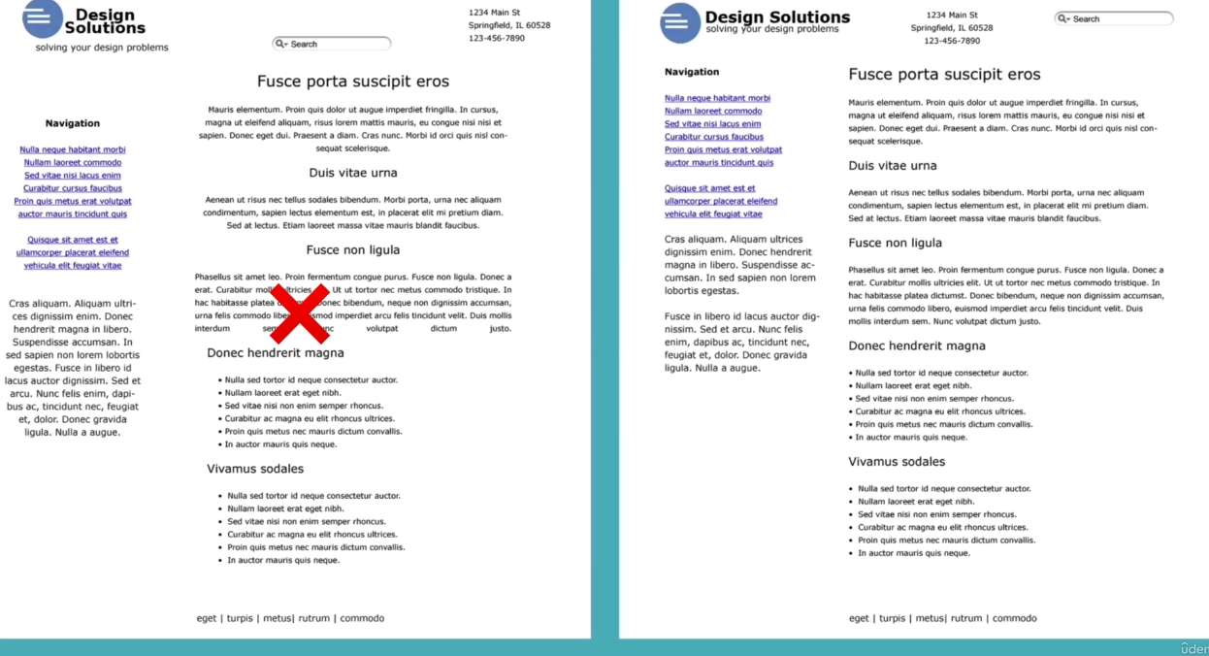

White space – the empty space around text or elements . Inject white space around elements look more luxurious – elevates it.

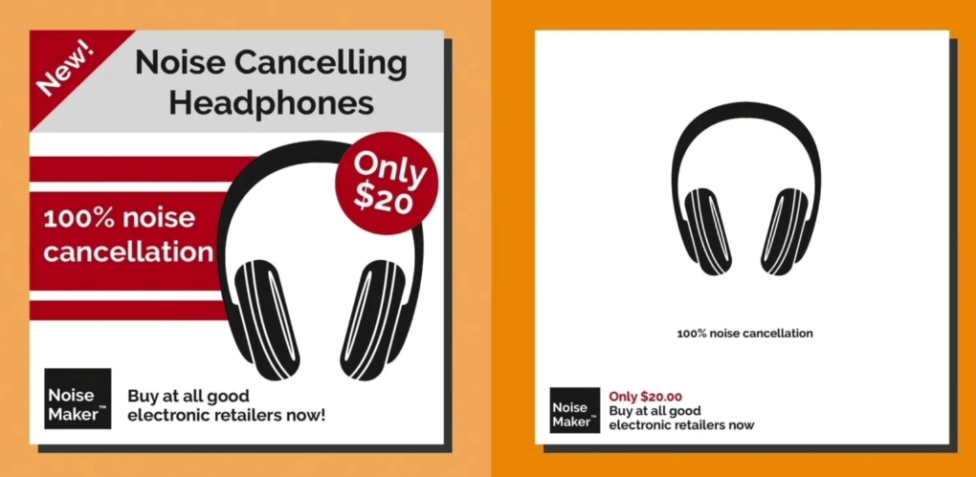

Audience - design for your audience – what mood do you want to convey 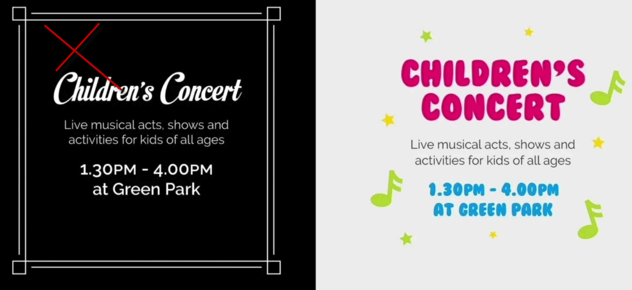

<https://collectui.com/>

<https://www.dailyui.co/>

72 UX design user experience

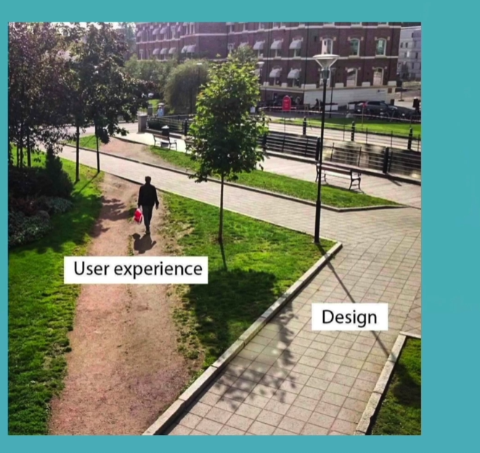

5 Things –

**Simplicity** – provide interest for eyes, consistent color scheme and typography

**Consistency** – keep the design consistent but also keep the functionality of product consistent

**Reading Patterns** – how peoples eyes track webpages and which parts they look at when browsing.

F pattern is common eyes start at top left track right and then flip back browsing down the left gutter.

Z pattern is also common eyes go from left to right zigzagging down the website – good if more sparse more video content – Facebook uses z

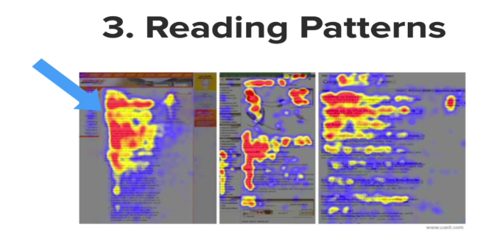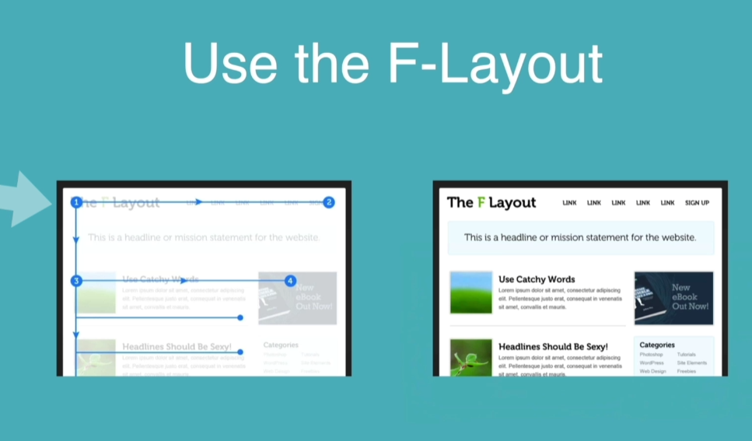

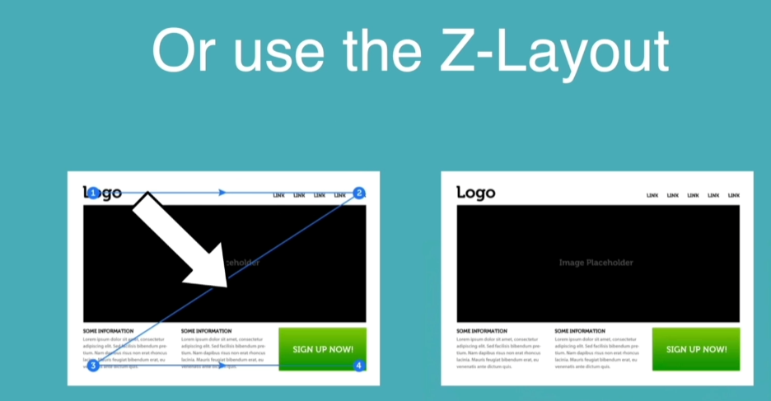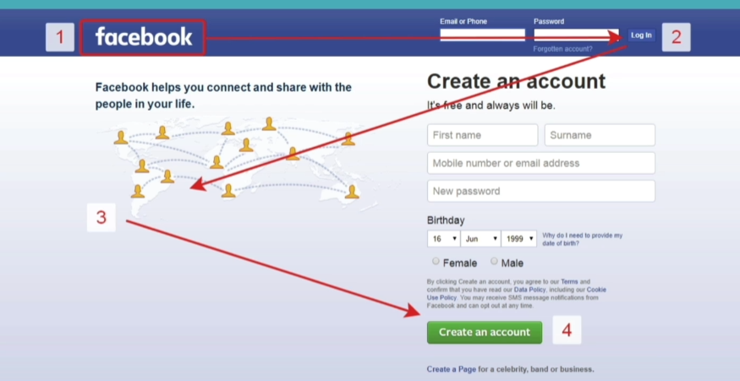

**Platform Design –** mobile first , but should work on desktop too

Website should re arrange itself when it is being rendered on a portrait smaller screen vs a larger desktop screen.

Don’t use too many banners

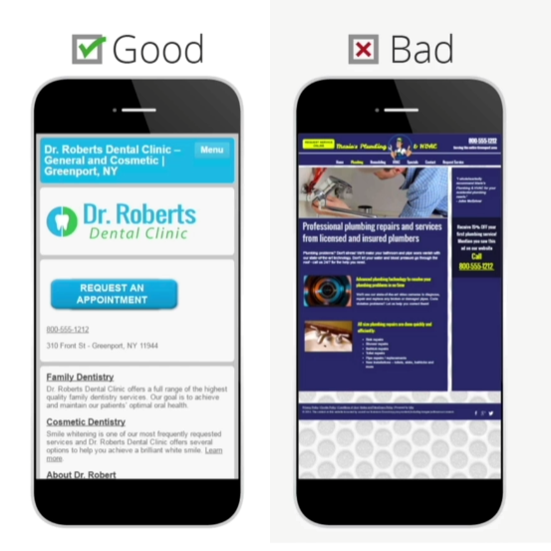

**Don’t use our powers for evil** – that is no dark patterns, that is patterns which get a user to perform an action or behavior that is beneficial to the company or the designer but it's not necessarily what the user wants.

Amazon is famous for this as with this button that defaults to paide delevery vs free

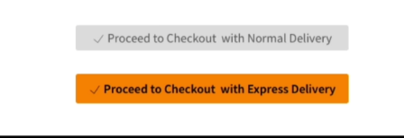

This one is tricking people into trying to swipe what looks like a hair off the screen….

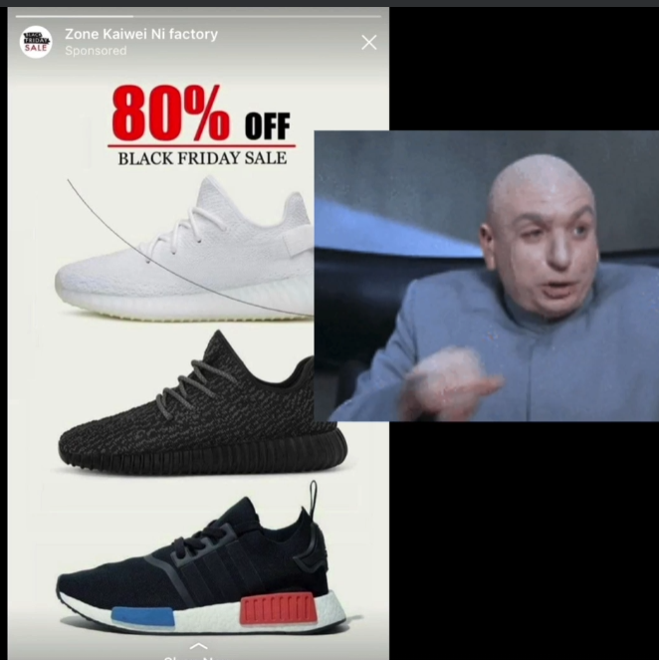

73 – Design a hotel website

74 Capstone –

Restart here

<https://www.udemy.com/course/the-complete-web-development-bootcamp/learn/lecture/19655710#overview>